

- 2026)
Mrs.Swathi
Saisashank.B
2520030454
CSE
CO – 3 Graph Algorithms & Optimization Techniques

Case Study Topic: CivicEye Emergency Response Optimization using Dijkstra Algorithm
Work Done Summary:
In this case study, we implemented Dijkstra’s Algorithm in the CivicEye Smart City Incident Monitoring & Response System to find the shortest path between monitoring zones. The system uses weighted graphs to represent city emergency routes and calculates the minimum emergency response time efficiently.

Implementation Details:
- Represented monitoring zones and city emergency routes using weighted graphs.
- Stored distances between connected monitoring zones as edge weights.
- Implemented Dijkstra’s Algorithm using Priority Queue.
- Calculated shortest distance from source city to destination city.
- Displayed optimized travel route with minimum distance.

Result: Screenshot/Output
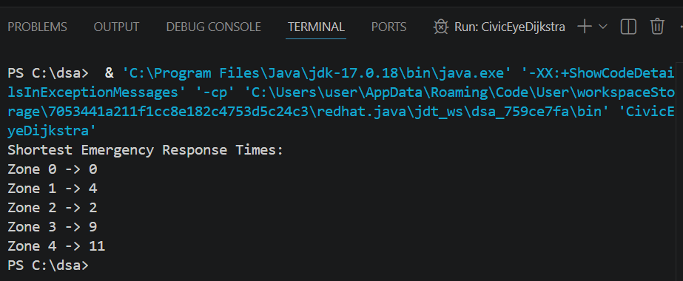

Dijkstra’s Algorithm successfully calculated the shortest travel route between monitoring zones.
The system reduced emergency response time and improved route optimization efficiency.
Compared to traditional searching methods, graph algorithms provided faster and more accurate route planning for large smart city monitoring networks.

GitHub Link: https://github.com/saisashank-netizen

